* -: We learned lot about the template of the approach.
* Before concluding this first part of the module, let's have a look at this suggestion username button here, it doesn't work But I added this suggest username method here where I created a default username.

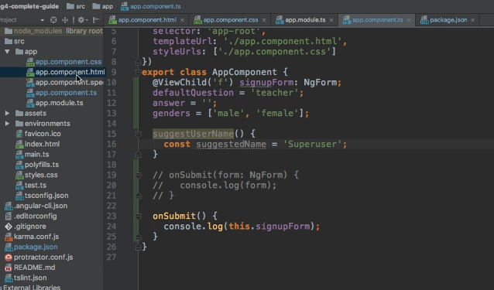

* Now it would be nice that up on clicking this button we populate this username input here with this username.
* Now you could think about some solutions using two-way data binding and they would probably work.
* You could two-way data bind this to a username property Which you then change with this method.
* I just want to show you a different approach.
* Remember that we do have access to this form here Through view child.
* Of course, it would be nice if we could set the value of one of our inputs, and turns out we can.
* For this, we get two different methods we can use.
* The first one would be on our sign up form, the set value property method here.
* This allows you to set the value of the whole form.
* And here we need to pass a JavaScript object exactly representing our form.
* So we need to use or set up user data, which is an object two, where we have, let's check, a username, field username.
* Set to the suggested name here and then also email, set to maybe an empty string and secret set to pet maybe.
* And question answer, keep in mind this is this text area here.
* So question, answer, set to an empty string.
* And last but not least, the gender, set to male.

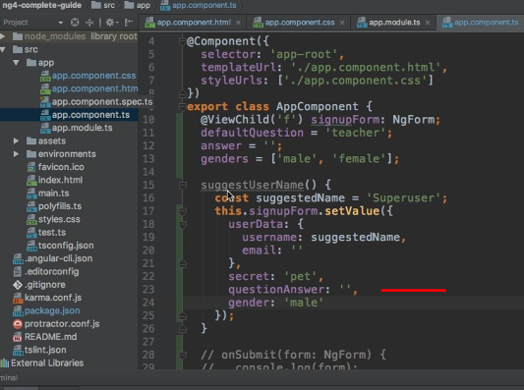

* And with this all added, let's go to our template and hook up this button, this button here, which is a type button so that it doesn't submit the form.
* And here I'll add a click listener and target these suggest username method.

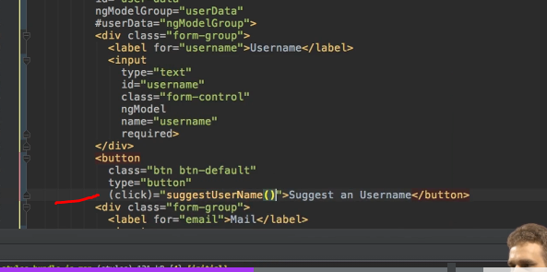

* So if this now recompiles and we hit this button, you see superuser was entered here.

* However, this approach does have one downside.
* If we already had some value entered there and then wanted to click suggest a username, it well, overrides all our other content.
* So this is not necessarily the best approach.
* However it does show you how you can set the values of all controls with one convenient command, with the set value command, where you pass an exact copy of the form, of the form value, I should say as a JavaScript object and can override the value of each control.
* Now, as mentioned, this is not the best approach.
* So let's comment it out.
* The better approach here would be to access the signup form and now actually the form object on it because signup form this overall NG form object is kind of the container of your form, you could say.
* And there you also have the patch value method.

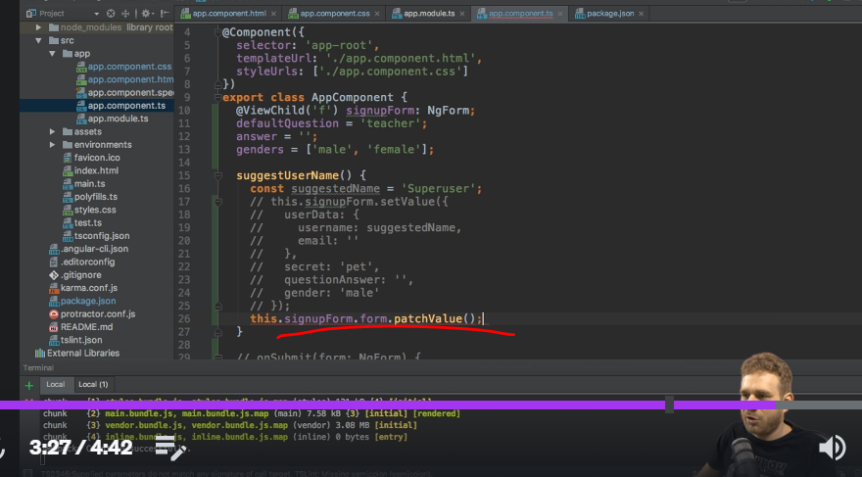

* So this is not available on the signup form itself but on the form group wrapped inside of it.
* And here you can pass JavaScript object two where you only override specific certain controls.
* So here you could also pass user data.
* Let me restructure this so that it's easier to read.
* User data, and then inside of user data, here, you might want to override the user name.
* Set it to it's adjusted name but don't override any other value.

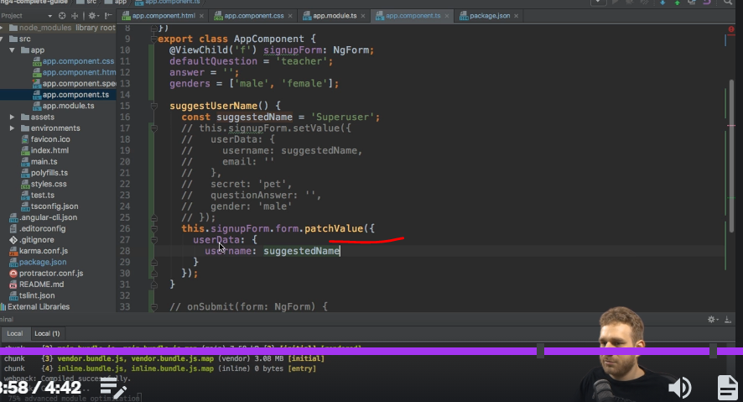

* So with this in place, if I now save this and I already have a email address entered and something here and here, and I click this button now it only added superuser and left all my other controls untouched.
* So set value and patch value important patch value only available on the form wrapped by NG form itself.

* As a side note, set value would be available here too.
* So these two commands are very helpful.
* Set value, to set your whole form.
* Patch value to override parts of the form.
* Very useful helper methods I wanted to bring to your attention.